University of the West of England

Department of Computer Science and Creative Technologies

Human Mind Model Hypothesis and Construction of Human Inner Frame by Experience

Submitted by: Xin Gao

Supervisor Name: Hisham Ihshaish

Student ID Number: 19013590

Date of Last Modified: 14th Dec, 2019

Word Count:

**Abstract**

In the past decades, artificial intelligence technology has gained a very remarkable events and achievements in academic and application fields. However, for artificial general intelligence, no one has the courage to stand up and show that have been done. Although this research is still a hypothesis, from another perspective, abstracts the human inner frame model and the changes and effects of personal experiences on the frame. Which may help researchers who are confused by the previous issues and lay a theoretical foundation for subsequent research work. Researchers still need to understand the relevant fields and adjust the entire viewpoint. The entire research involves artificial intelligence, computational psychology, computer science, genetic biology, and bioinformatics.

Main audience: Artificial intelligence, psychology, robotics, machine learning scholars

Key words: Mind model, Experience impact, Self-optimizing inner frame, Spontaneous AI

**Introduction**

The main purpose for this research is to explore the possibilities of AGI (artificial general intelligence) and lay the foundation for further research. Before going into a wider discussion, people should first clarify our starting point and reiterate the definition of intelligence. According to GOTTFREDSON, L.S. (1997), there are 52 related researchers jointly signed statement on intelligence. They defined intelligence as a general mental capability which can plan, proof, solve problems, think abstractly, understand complex ideas, learn quickly and learn from experience. Unlike learning and memorizing fixed content, intelligence is more inclined to depict the ability to understand and abstract real problems and environments. It is not a simple personality trait, but an abstract and general ability to face dynamic multifaceted problems.

Intelligence is a complex system. People eat, sleep, and study, and they use their intelligence all the time.

When people want to make human-like intelligence, they should also understand whether the things they want to create are roughly the same in intellectual performance, otherwise scholars will call it artificial mental retardation in the face of machines with different intelligence. It is unclear whether the performance of the hardware determines the intelligence efficiency of artificial intelligence or the algorithm framework determined. However, when scholars confused about this issue, maybe they can turn back to the human intelligence. If the general level of human’s intelligence is roughly equal? There are some IQ tests maybe can give some inspirations. IQ test is a question set to test the approximate intelligence level of the test subject. According to Mackintosh and Mackintosh (2011), human’s intelligence performance is normally distributed as mean 100 and standard deviation 15.

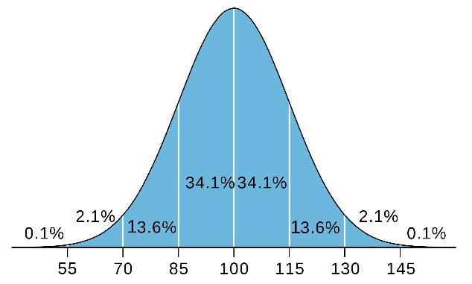

Figure 1: Human’s general intelligence quotient distribution

However, there are three basic doubts about this. Whether these tests are scientific and whether the results of personal IQ tests will change in a long-life, and in the traditional IQ test problem set, do these tests have a certain tendency? For example, students who are rich in mathematics and logic are more likely to get higher scores than students who like to play football. When some children suddenly realize some truth at some point in their lives and can make their IQ scores improve quickly or children in industrially developed countries are more likely to score higher than children in the third world. These are not easy problems to solve. However, maybe there is the answer to the perspective of long human history and genetics. As Dod et al. (1989) state that in the sequencing the genes of mice in a region, they showed the characteristics of gene homogenization. Besides, the paper pointed out that the selection of breeding offspring in a fixed area has more likely happened gene homogenization. In the long history of human beings, people's genes are also likely to be mixed in a wide range of interracial and cross-regional breeding offspring. Although there is a significant gap between people, in fact in a long-term perspective the gap of this is minimal. 1000 Genomes Project Consortium (2015)’s work shows that more than 99.6% of human’s gene are no difference. If the genes determine the structure of our bodies, the hardware basics of the human brain should in a highly degree of similarity, even between Africans and Asians who look very different.

Move back to the IQ test’s performance, what determined the final performance in the IQ test among the different people? Maybe that caused by education, more time for individual thinking, good family supporting and targetable training for the IQ test. There is almost no absolute evidence that any high IQ is inherent. The more general reason is when the person in their child, the experience and family environment are more able to think and love to deal with logical problems. Compare with third world area, developed countries have more competitive advantage in IQ tests. For example, in the developed countries, caused by the industrialization people have more free time to get education and more time to thinking. The knowledge is more advance compare with third world people. Besides, the developed countries have a more relaxed environment gives birth to ideas. In addition, in third world area or even in some undeveloped countries, child may be faced with hunger and danger daily. The education quality is also a problem need to be concerned. That the reason researcher believes the crueler lives cause students to perform worse on IQ tests in general.

From the perspective of computer science, it should be called a framework model that has shaped the inner world of human beings by experience. This is back to our topic on artificial intelligence, Alpha Go has a good record in the game against Li Shishi. With training in multiple dimensions within the framework of deep learning, human’s machine defeated the Go master. However, such a powerful robot can't handle daily affairs like a normal person. The reason is the training method, this machine learning model has only experience with human Go, but no experience with daily life. Like a primitive man who just came to the city from a tropical rain forest tribe, he may be very good at hunting, but he cannot get a good score in the IQ test. In other words, he has no experience in this area.

Researchers' hypothesis is that experience has shaped our attitude towards the world step by step. Our inner framework may change because of experience. For example, when people were young, they felt that test scores were the most important thing in life. However, then they almost never took the test when they older, they changed their attitude towards the importance of test scores. In other word, we are continuously being changed by our experience. Some are active and some are passive. Maybe not gene caused our IQ test score, but the memory and experience.

**Things to do in the future**

To test my hypothesis, I want to develop a machine model with experience based. That will be a small game’s enemy AI. The AI will grow up with the experience and be stronger and stronger. The initial code may be not so mass, and the AI can code by itself by experience and change their strategy.

References:

1000 Genomes Project Consortium (2015) A global reference for human genetic variation. *Nature* [online]. 526 (7571), pp.68.

Dod, B., Mottez, E., Desmarais, E., Bonhomme, F. and Roizes, G. (1989) Concerted evolution of light satellite DNA in genus Mus implies amplification and homogenization of large blocks of repeats. *Molecular Biology and Evolution* [online]. 6 (5), pp.478-491.

GOTTFREDSON, L.S.Mainstream Science on Intelligence: An Editorial With 52 Signatories, History, and Bibliography. [online].

Mackintosh, N. and Mackintosh, N.J. (2011) *IQ and Human Intelligence* [online]. Oxford University Press.